Chapter 3 Living systems
extra worksheet 1: Respiratory diseases
Science understanding, Science as a human endeavour
Getting oxygen into your body is vital for our survival. Many different diseases of the lungs and respiratory system prevent you from being able to breathe as deeply as normal and breathing may cause you to cough or wheeze. Common diseases of the lungs include asthma, emphysema, bronchitis and pneumonia. These diseases may be chronic, which means they are long lasting or occur over and over again. Other diseases are acute, which means they come on rapidly and last a short time.

Asthma
Asthma is a chronic disease in which the bronchi in the lungs are swollen and tender. In this condition the bronchi react to factors in the environment, known as triggers. Triggers such as tobacco smoke, dust and pollens cause muscles in the walls of the bronchi to contract, making the airways narrow, as shown in Figure 3.1.1. The cell lining of the bronchi produces extra mucus. The mucus reduces the space inside the bronchi even more and the person has difficulty breathing.
When people with asthma feel an attack coming on, they use Ventolin puffers. The puffer contains chemicals that relax the muscles of the bronchi. This allows the bronchi to open up and the person is able to breathe freely again.
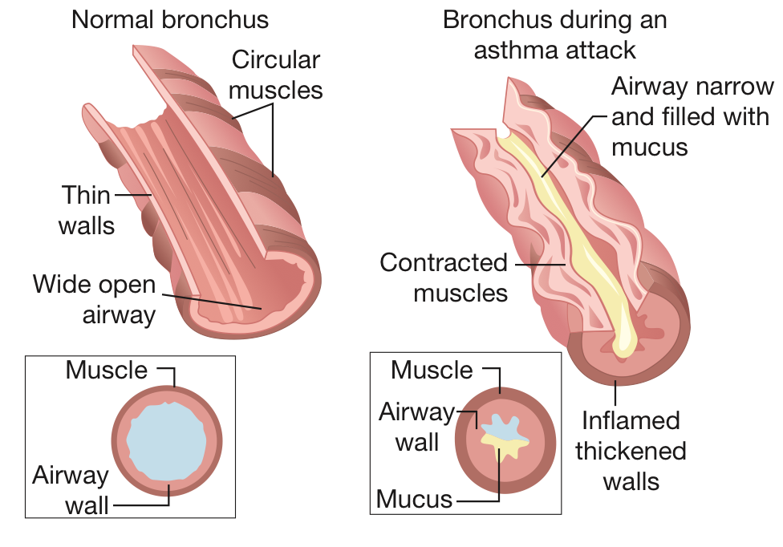
Figure 3.1.1
The passage through which air can pass is very narrow during an asthma attack.

Emphysema
Emphysema is a chronic lung disease in which the bronchi, alveoli and blood capillaries are damaged. Emphysema is usually caused by smoking or long-term exposure to air pollutants (chemicals) and dust.
The tissues of healthy bronchi and alveoli are elastic, which means that they are able to stretch and then return to their original shape. When bronchi and alveoli are exposed to pollutants and dust over long periods of time, they lose their ability to stretch. The bronchi become narrow and the alveoli break. Damage to the alveoli creates larger spaces within the lungs. Having large spaces reduces the surface area for gas exchange. The blood capillaries surrounding the alveoli are also damaged and less carbon dioxide and oxygen can be carried to the alveoli and away from them.
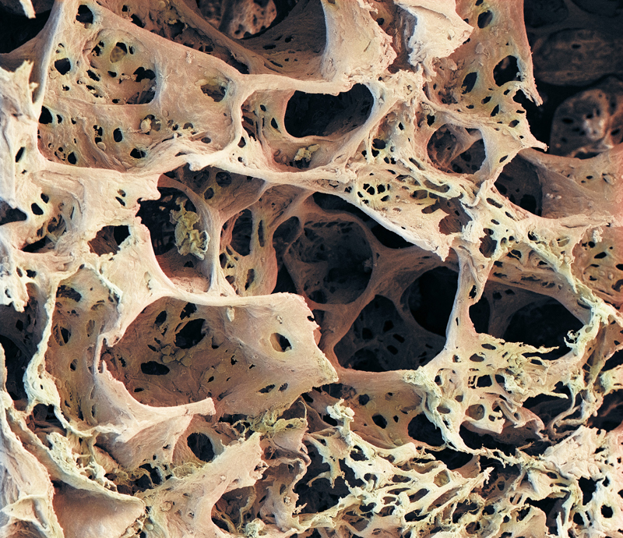
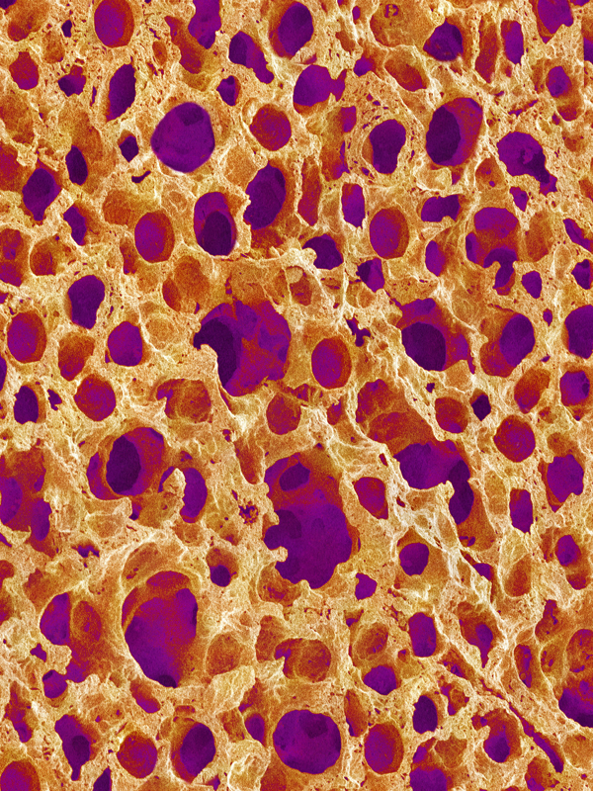
Compare the photograph of the alveoli of a person with emphysema with the alveoli of a healthy person shown below.

Figure 3.1.2 Figure 3.1.3
Alveoli of someone suffering from emphysema Alveoli of a healthy person.
People with emphysema become breathless during physical activity and frequently have chest infections. They often have a bluish colour to their skin, especially around their lips. This bluish colour is known as cyanosis and is caused by a lack of oxygen in their blood.
Emphysema develops slowly. Damaged alveoli and tissues of the bronchi do not repair themselves so the damage is permanent. A person with advanced emphysema has to breathe hard in an attempt to exhale fully and to get enough air into their lungs. Open your mouth as wide as it can go and then try blowing out a candle or match without making an ‘O’ shape with your lips. It is difficult. This is what breathing is like for people with emphysema, all the time.

Questions
1 a Explain the difference between a chronic and an acute disease.

b State whether asthma is an acute or chronic disease. Explain your choice

2 Refer to Figure 3.1.2. Propose the effect these holes in the alveoli would have on the person’s breathing.

3 Construct a flow diagram of events from the trigger to an asthma attack.

4 Explain why people with advanced emphysema often have a bluish tinge to their lips.

5 Explain why smoking is not good for the health of your lungs.

6 In many parts of Australia there is a distinct dry season. Explain why the dry season would be a difficult time for people who suffer from asthma.

7 Many coal miners used to suffer from emphysema. Propose why they suffered from it.

8 Compare asthma and emphysema using the table below.
 | Asthma | Emphysema
Cause
Chronic or acute
Part of respiratory system affected
Treatment

